**Performance of example management procedures for Atlantic bluefin tuna**

Tom Carruthers[1], Doug Butterworth[2]

*SUMMARY*

Two example management procedures are described that calculate total allowable catches using relative abundance indices. The management procedures are tested in the ABT-MSE framework and evaluated according to various performance statistics. Trade-offs among performance metrics and between the two stocks are also characterized.

*KEYWORDS*

*Management Strategy Evaluation, bluefin tuna, operating model, management procedure*

# Introduction

In this paper two example management procedures (MPs) are described that modify Total Annual Catches (TACs) according to indices of relative abundance. The MPs are tested using the ABT-MSE package alongside four constant catch MPs. Readers are directed to supporting SCRS papers for a full description of the operating models (SCRS/2015/179, SCRS/2017/223), the data used in conditioning (SCRS/2015/180, GBYP 2017) and the software package (SCRS/2017/225). Additionally there are number of peer-reviewed papers that describe the MP approach to fisheries management (e.g. Punt and Butterworth 1999, Cochrane et al. 1998, Punt et al. 2015).

# Methods

Two example management procedures are tested for the reference case (RC) operating model (the central OM from the RS (OM #1) that uses the best model estimates of abundance for both stocks, high natural mortality rate and low age at maturity (SCRS/2017/223). The first, EMP1 is a very simple index target MP that makes incremental adjustments to the TAC depending on the proximity of recent index observations to a target index level. The second MP, EMP2 originates from Rademeyer and Butterworth (2015), and in addition to proximity to a target level accounts for changes in the slope of indices (whether there is a positive or negative trend). Both of these MPs are empirical; they calculate TACs directly from abundance indices.

***Example Management Procedure 1***

EMP1 is a very simple index target MP. For each year *y*, that the TAC is calculated, three inputs are required: the previous TAC recommendation, a mean abundance index *Jy-1* over the most recent five years $J_{y-1}=\frac{1}{5}\sum_{y-5}^{y-1}{I_{y}}$ and a target level for that index *Jtarg*.

The MP either decreases the TAC by 10%, keeps the TAC the same, or increases the TAC by 10% depending on the ratio of the mean index *Jy-1* to the target index *Jtarg*:

(1)

${TAC}_{y}={TAC}_{y-1}∙\left\{\begin{matrix}0.90 & J_{ratio,y-1}<0.6 \\ 1 & 0.6<J_{ratio,y-1}<1.4 \\ 1.1 & J_{ratio,y-1}>1.4\end{matrix}\right.$ (2)

***Example Management Procedure 2***

EMP2 is somewhat more complex and provides TAC adjustments accounting for both the ratio of the current index to the target index *Jratio*, and also for its longer-term trend *s*.

 (3)

where

 is the slope of a log-linear regression of the index against year over the last six years (*y*-6 to *y*-1);

, are control parameters that determine the sensitivity of TAC adjustments.

Similarly to EMP1 (where only TAC changes of +/- 10% are permitted), EMP2 constrains the maximum inter-annual change in the TAC to 15% (both up or down).

A list of the EMP1 and EMP2 control parameter values used can be found in Table 1.

***Indices and control parameters***

For these examples, the Japanese Longline index for the North East Atlantic (JPLL_NEAtl2) was used for setting TACs for the eastern area, while the Gulf of Mexico Larval Survey (GOM_LAR_SUV) was used for setting TACs in the west. Mean values for these indices over the last 5 years were approximately 6 for the Japanese Longline index and 0.6 for the Gulf of Mexico Larval index.

Values were chosen for the target index levels and up/down control parameters to attempt to achieve an appropriate trade-off amongst performance statistics for conflicting objectives (such as high catches and low risk of unintended resource depletion).

***Other ‘management procedures’ for performance comparison***

Four other management procedures were evaluated to frame the performance of the example management procedures. These included four constant catch MPs that specified zero catches (ZeroC), or 50%, 100% and 150% of current catches (CurC50, CurC100, CurC150, respectively); these current catches are 13 500 t for the eastern area and 2 000 t for the west.

***Performance measures / statistics***

A total of 13 performance statistics were defined (Table 2, see CMG 2017) that evaluate MPs according to expected magnitude of catches (C10, C20, C30), stock depletion relative to unfished (D10, D20, D30, LD), stock depletion relative to a zero catch scenario (DNC, LDNC), fishing rate and status relative to MSY reference points (POF, POS, PGK) and variability in catches (AAVC). These performance statistics are consistent with MSE applications elsewhere (REFs) and intended to encompass a range of stakeholder interests.

# Results

The MPs were tested using the reference case operating model (OM#1), which simulates two resilient populations in relatively optimistic states (e.g. high natural mortality rate, low age at maturity, high current spawning biomass relative to unfished). Similarly to other operating models, recent recruitments are estimated to be relatively strong,which leads to stock biomass increases in early projection years for the majority of the simulations (Figure 1).

With respect to certain performance metrics relating to conservation (see Figures 1 and 2), the performance of most MPs was both comparable and satisfactory. For example, all MPs provided close to a 100% probability of being in the green Kobe zone (PGK, both underfishing and underfished status) after year 30 of the projection (Figure 3). For EMP2 however, the strong downward trends in future catches are clearly not satisfactory – remember though that EMP1 and 2 are intended purely to illustrate how the process works – they have NOT been tuned to give optimal trade-offs.

Other performance statistics such as the lowest level of stock depletion (LD) varied substantially among the MPs and were generally traded-off with short-term and long-term catches (C10, C30) (Figures 2 and 3).

For the most part, MPs that performed well in the East also performed well in the West (Figure 4) meaning that if these were the only candidates Western performance would not be traded-off against Eastern performance. However this pattern may not be maintained as greater complexity is introduced to the MPs to be considered in the future

Static constant catch MPs (e.g. 150% of the current TAC, CurC150) performed reasonably well compared with the example MPs, EMP1 and EMP2. However again this is a pattern that may not continue once the other Reference Set and robustness tests are introduced.

# Discussion

The purpose of this document is to introduce MP design and demonstrate example MPs. MSE processes are strengthened by comparative testing of multiple MPs developed by a number of different scientists. EMP1 and EMP2 are deliberately simple – they are intended to be illustrative of the process only, and their results shown here should not be over-interpreted. Theycould easily be improved by modification or the tuning of control parameters.

In general dynamic MPs that react to current data regarding relative abundance can be expected to comprehensively outperform static MPs such as 150% of current TAC (CurC150) (Carruthers et al. 2014, Harford and Carruthers 2017). The relative strength of static MPs in this preliminary analysis indicates that future MP development will lead to substantial performance gains over the example MPs presented in this paper.

It is important to note that other operating models that include more conservative assumptions about stock status and productivity may be a harder test of MPs and offer a different view of their relative performance.

A follow up paper (SCRS/2017/225) provides a description of the R package for MP testing (ABT-MSE) and a full worked example of how to code EMP1 and EMP2 into the package and produce the results tables and figures of this paper.

# Acknowledgements

This work was carried out under the provision of the ICCAT Atlantic Wide Research Programme for Bluefin Tuna (GBYP), funded by the European Union, several ICCAT CPCs, the ICCAT Secretariat and by other entities (see: http://www.iccat.int/GBYP/en/Budget.htm). The contents of this paper do not necessarily reflect the point of view of ICCAT or other funders and in no ways anticipate ICCAT future policy in this area.

# References

ABT-MSE. 2017. Atlantic bluefin tuna management strategy evaluation: an R package. Available at: [accessed September 2017]

Butterworth, D.S., Punt, A.E., 1999. Experiences in the evaluation and implementation of management procedures. ICES J. Mar. Sci. 56, 985-998.

CMG. 2017. Specifications for MSE trials for bluefin tuna in the North Atlantic. GBYP Core Modelling Group. ICCAT Atlantic Wide Research Programme for Bluefin Tuna. Available at: [accessed September 2017]

GBYP. 2017. Data to inform operating models for North Atlantic bluefin tuna. ICCAT Atlantic Wide Research Programme for Bluefin Tuna. Available at: [accessed September 2017]

Carruthers, T.R., Punt, A.E., Walters, C.J., MacCall, A., McAllister, M.K., Dick, E.J.,Cope, J., 2014. Evaluating methods for setting catch limits in data-limited fisheries. Fish. Res. 153, 48–68, http://dx.doi.org/10.1016/j.fishres.2013.12.014.

Cochrane, K L., Butterworth, D.S., De Oliveira, J.A.A., Roel, B.A., 1998. Management procedures in a fishery based on highly variable stocks and with conflicting objectives: experiences in the South African pelagic fishery. Rev. Fish. Biol. Fisher. 8, 177-214.

Harford, W., Carruthers, T.R. 2017. Interim and long-term performance of static and adaptive management procedures. Fish. Res. 190: 84-94.

Punt, A.E., Butterworth, D.S., de Moor, C.L., De Oliveira, J.A.A., Haddon, M., 2016. Management strategy evaluation: best practices. Fish Fish. 17, 303–334, <http://dx.doi.org/10.1111/faf.12104>.

Radermeyer, R.A., Butterworth, D.S. 2015. An illustrative example of a management procedure for Eastern North Atlantic bluefin tuna. ICCAT SCRS/2015/165.

**Tables**

**Table 1.** Control parameters for Example Management Procedures 1 and 2 (EMP1, EMP2)

|  |  |
| --- | --- |
| Control parameter | Value |
| *up* | 0.05 |
| *down* | 0.15 |
| *up* | 0.05 |
| *down* | 0.15 |
| *J*targ -JPLL_NEAtl2 (East MP) | 4.8 |
| *J*targ - GOM_LAR_SUV (West MP) | 0.66 |

**Table 2.** Performance measures / statistics used to evaluate the performance of management procedures

|  |  |
| --- | --- |
| **Performance Measure** | **Abbreviation** |
| a) Annual average catch for the first, second and third 10-year period of MP application | C10, C20, C30 |
| b) Spawning biomass depletion calculated relative to the deterministic equilibrium in the absence of catches for the recruitment function that applies after 10, 20 and 30 years of MP application. | D10, D20, D30 |
| c) The lowest spawning biomass depletion over the 30 years for which the MP is applied calculated relative to the deterministic equilibrium in the absence of catches for the recruitment function that applies after 30 years. | LD |
| d) Spawning biomass depletion after 30 years, but calculated relative to the trajectory that would have occurred had no catches been taken over the full period for which MP application is being considered. | DNC |
| e) The lowest spawning biomass depletion over the 30 years for which the MP is applied, but calculated relative to the zero catch trajectory specified in d). | LDNC |
| f) Kobe indicators: Probability of Overfishing (F>FMSY), Probability overfished state (B < BMSY), Probability green Kobe (F<FMSY and B>BMSY) over 30 projected years | POF, POS, PGK |
| g) Average annual variation in catches defined by: | AAVC |
|  |  |

**Table 3.** Performance statistics for the 6 MPs for the East and West stocks (see Table 2 for definition of performance statistics). Catch statistics (C10, C20 and C30) are reported in units of thousand metric tonnes. Probability statistics such as probability of overfishing (POF), probability of overfished status (POS), probability of green Kobe zone (PGK) are reported as percentages, as is the inter-annual variability in catches (AAVC).



**Figures**

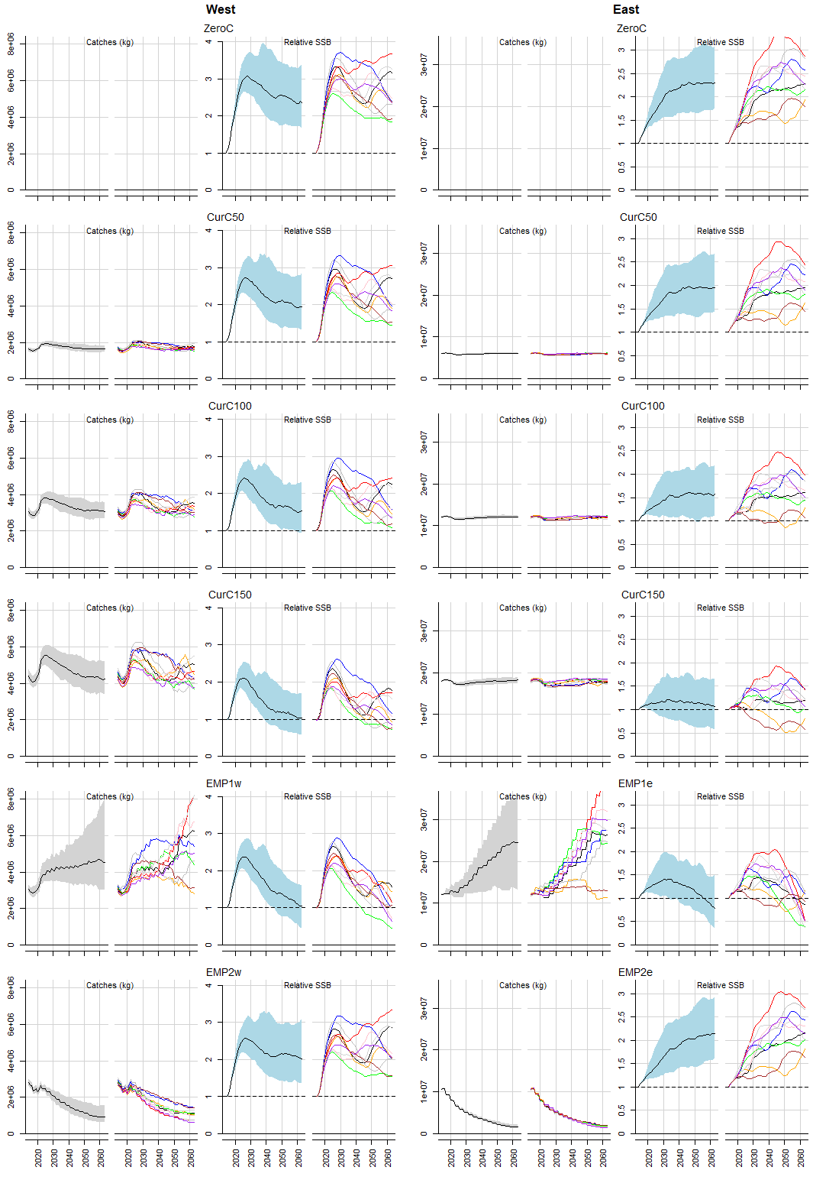

**Figure 1.** Catch and SSB trajectories for 6 MP pairs (98 simulations, OM #1). Each pair of MPs operates on the existing western and eastern areas. The result plotted here are for the West and East stocks. Each row is an MP pair. Relative SSB is the projected SSB relative to that in the first year of the projection (expressed as a fraction of 2016 SSB). For both catch and SSB the median estimate of all simulation is a solid line with the grey shaded region representing the 5th and 95th percentiles. Colored lines represent 10 individual simulations (worm plots). CurC represents current catch MPs. CurC50, CurC100 and CurC150 are 50%, 100% and 150% of current catches.

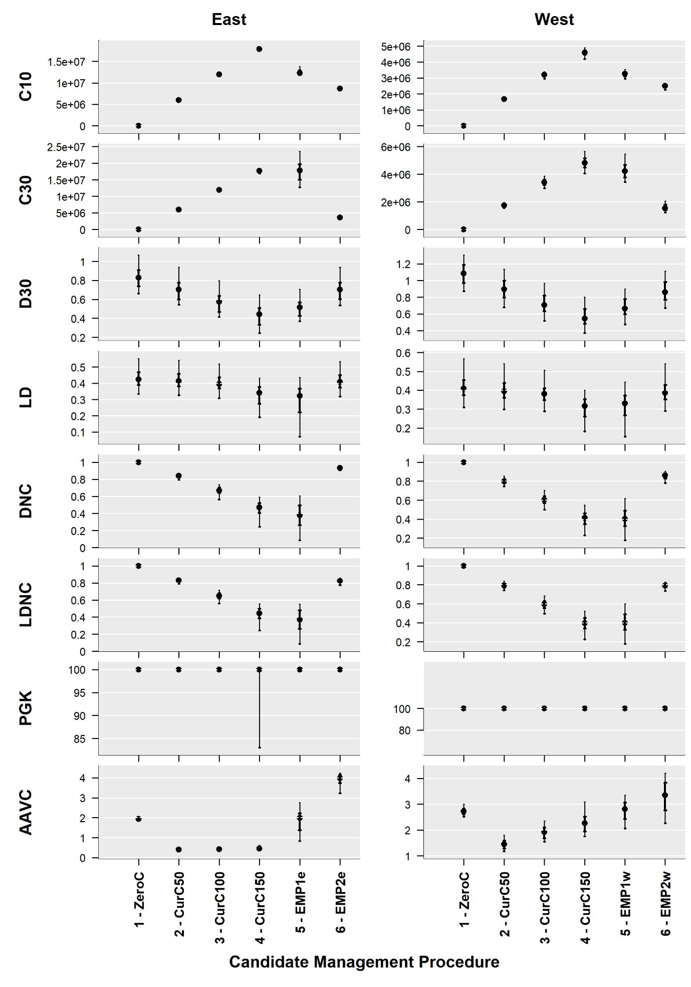**Figure 2.** Performance of the 6 example management procedures. Points represent medians (n=96), bold bars are 50% probability intervals and thin bars are 90% probability intervals. Mean catches over the first 10 years and 30 years of the projections (C10, C30) are in units of tonnes.

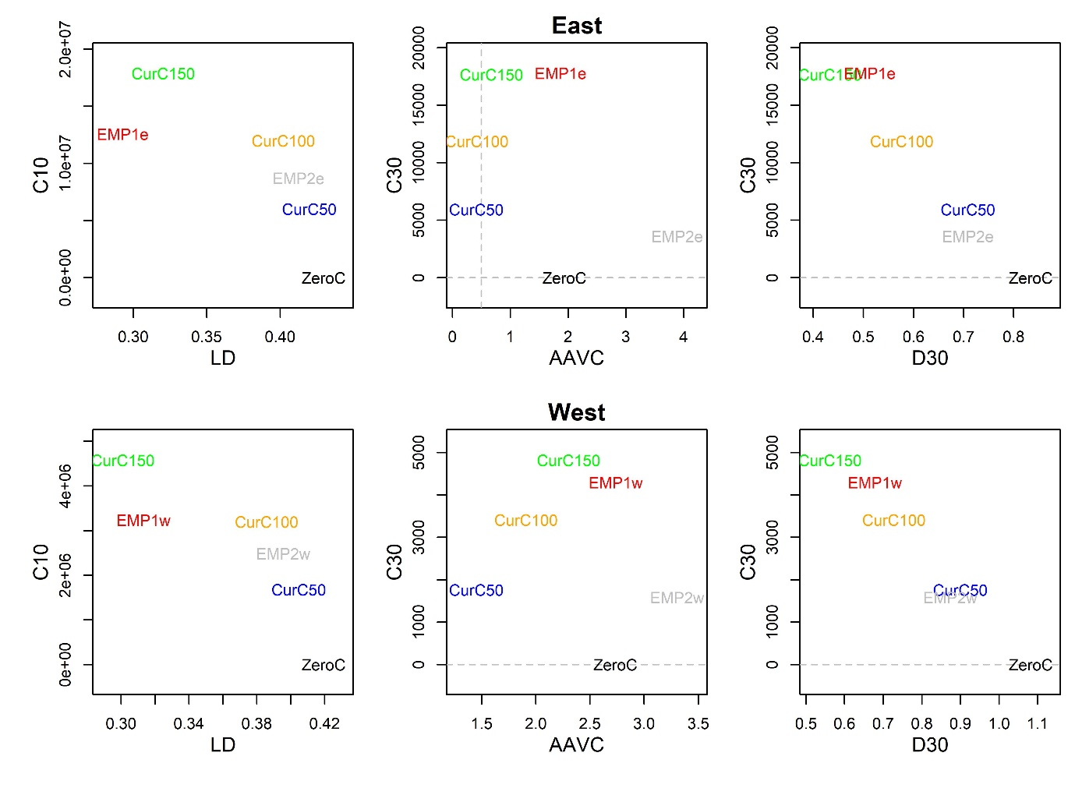

**Figure 3**. Trade-off among performance metrics within East and West stocks.

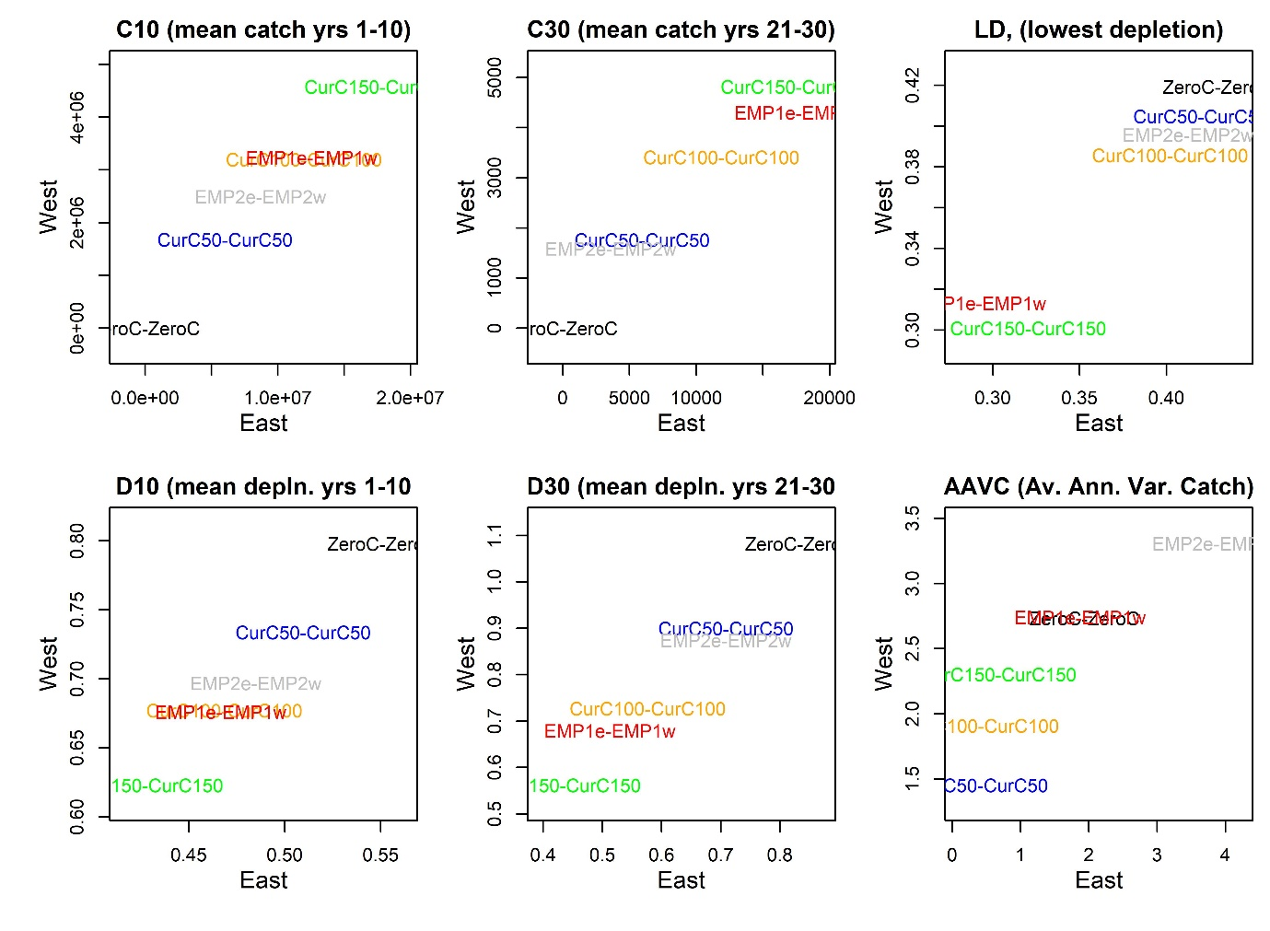

**Figure 4**. Performance metrics trade-off among East and West stocks.

1. IOF, 2202 Main Mall, University of British Columbia, Vancouver, B.C., Canada, V6T 1Z4. [t.carruthers@oceans.ubc.ca](mailto:t.carruthers@oceans.ubc.ca)
2. Department of Mathematics and Applied Mathematics, University of Cape Town, Rondebosch 7701, South Africa. [doug.butterworth@uct.ac.za](mailto:doug.butterworth@uct.ac.za)